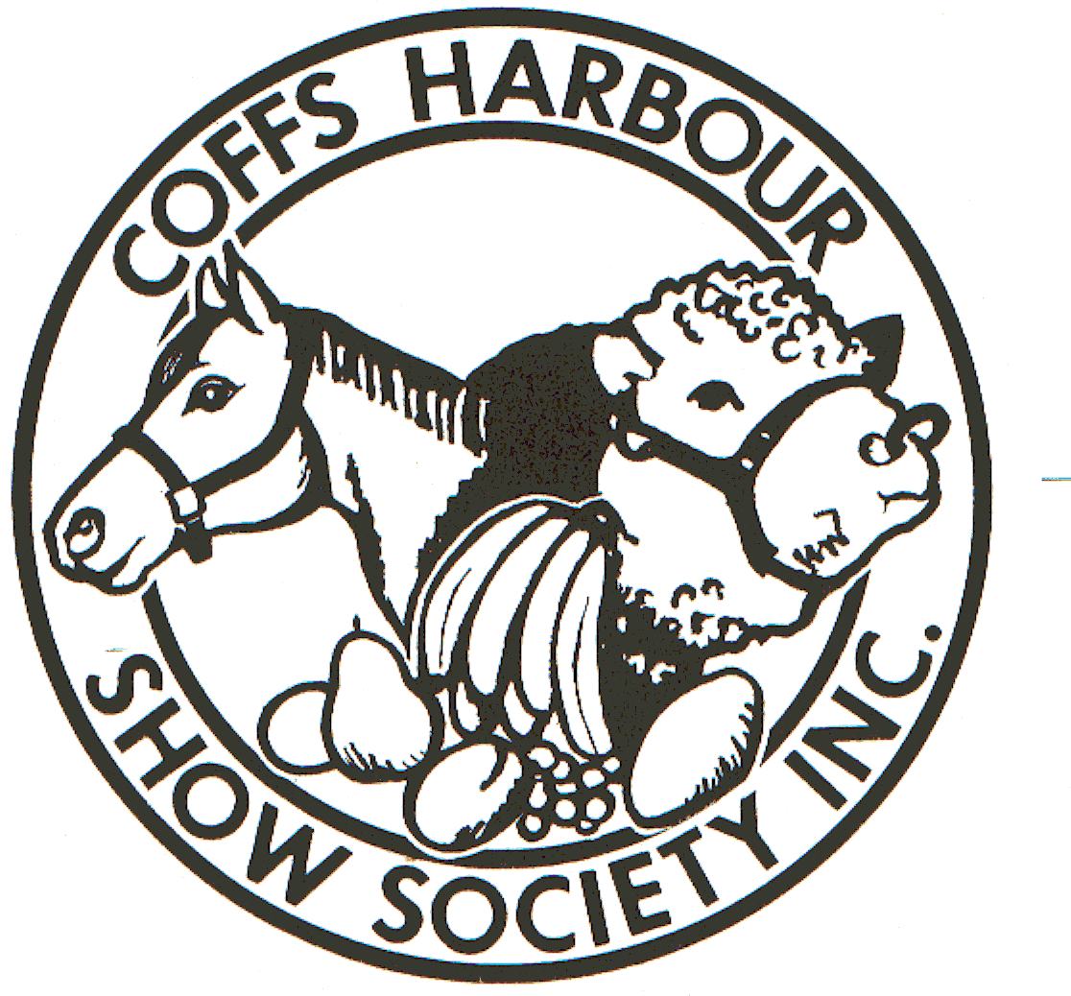
Coffs Harbour Agricultural Show

15-17 May 2015

Coffs Harbour Showgrounds 123 Pacific Highway Coffs Harbour 2450 PIC # NJ285702

www.coffsharbourshowsociety.com.au

Ring Coordinator Lorraine White: email white191@bigpond.net.au
Stable Manager Pam Corbett: phone 0457 432 335

Secretary Margo Caba: email coffsshow@aim.com

HENDRA VIRUS: Hendra vaccination is not compulsory but due to the presence of flying fox in the mangroves, Hendra vaccinated horses will have first priority for stable bookings. Please note: If there were to be a Hendra case diagnosed, unvaccinated horses would not be allowed home until the quarantine period ended.

All exhibitors are encouraged to participate in the Grand Parade commencing at 2.30pm on Saturday. All exhibitors leading, riding or driving an animal will go into the lucky draw for
$1000 cash
donated by Frances Blake

CHANGED ENTRY POINT: Horse section vehicles proceed directly to stable area. Show entry tickets will be available from ENTRY GATE at rear of Showground.

WEEKEND PASSES available for competitors only in 2015
DAILY GATE PRICES
Adult . . . . . . . . . . . $15 16 years & over
Child . . . . . . . . . . . $10 3-15 years
Aged Pension . . . . $10 please produce card
Disability Pension $10 please produce card
Family Day Ticket $40 2 Adults up to 4 children (arriving together)
Led Horse & Pony Club Saturday Ring 1 pages 2-3
Led Pony & Miniature Horse Saturday Ring 2 pages 4-6
Sporting Saturday Ring tba page 7
English/ Western Saturday Ring 3 pages 8,10,11
Heavy Horse Led Saturday Ring 3 page 9
Showjumping Sat & Sunday page 12
Ridden Pony Sunday Ring 1 page 13
Ridden Galloway & Off the Track Sunday Ring 2 page 14
Off The Track entry form page 15
Ridden Hack Sunday Ring 3 page 16
Harness & Heavy Horse Ridden Sunday Ring 4 page 17
Conditions page 18
Addresses eligible for DISTRICT events page 19
Summary of Special Prizes page 20

Stable & Camping see separate form
Waiver & risk warning separate form
Record of attendance separate form
LED HORSE Ring 1 8am Saturday
All LED horses must be registered with their respective Breed Society & handlers able to produce papers if required.
ENTRY FEE $4 per class
PRIZE MONEY $10 first, $6 second, $4 third unless states otherwise RIBBONS to 3rd place
LED REGISTERED
GUY FAWKES HERITAGE HORSE Sponsored by the GUY FAWKES HERITAGE HORSE ASSOCIATION Inc.
101. Guy Fawkes Heritage Horse Led Maiden
102. Guy Fawkes Heritage Horse Led U/3yrs (filly, colt, gelding)
103. Guy Fawkes Heritage Horse Led Mare
104. Guy Fawkes Heritage Horse Led Gelding
105. CHAMPION & RESERVE CHAMPION Guy Fawkes Heritage Horse Sash to Champion courtesy GFHHA inc.
(Winner of classes 101 to 104 eligible)
AUSTRALIAN BRUMBY HORSE - ABHR Sponsored by the AUSTRALIAN BRUMBY HORSE REGISTER
(Pure Bred Brumbies only in these classes. Registration papers will be required by Ring Steward)
106. Stallion or Colt
107. Mare or Filly
108. Gelding
109. CHAMPION & RESERVE CHAMPION Australian Brumby Horse $50 to Champion courtesy ABHR

(Winner of classes 106 to 108 eligible)

AUSTRALIAN STOCK HORSE - ASH
110. Stallion or Colt
111. Mare or Filly
112. Gelding
113. CHAMPION & RESERVE CHAMPION Australian Stock Horse (Winner of classes 110 to 112 eligible)

ARABIANS PUREBRED
114. Stallion or Colt
115. Mare or Filly
116. Gelding
117. CHAMPION & RESERVE CHAMPION Arabian Purebred (Winner of classes 114 to 116 eligible)

ARABIANS PARTBRED ARABIANS – PARTBRED, ANGLO & PONY
118. Stallion or Colt
119. Mare or Filly
120. Gelding
121. CHAMPION & RESERVE CHAMPION Arabian Part bred (Winner of classes 118 to 120 eligible)

WARMBLOODS PURE & PARTBRED
122. Stallion or Colt
123. Mare or Filly
124. Gelding
125. CHAMPION & RESERVE CHAMPION Warmblood (Winner of classes 122 to 124 eligible)

THOROUGHBRED
126. Stallion or Colt
127. Mare or Filly
128. Gelding
129. CHAMPION & RESERVE CHAMPION Thoroughbred (Winner of classes 126 to 128 eligible)

ANSA – Preference given if ANSA attired
130. Stallion or Colt
131. Mare or Filly
132. Gelding
133. CHAMPION & RESERVE CHAMPION ANSA (Winner of classes 130 to 132 eligible)
134. Ring 1 SUPREME CHAMPION Registered Led Horse sash, trophy & (winner of classes 105,109,113,117,121,125, 129, 133 eligible) NORCO RURAL voucher RIDDEN REGISTERED
135. Ridden ANSA
136. Ridden Guy Fawkes Heritage Horse Open
137. Ridden ABHR Brumby
138. Ridden Stock Horse ASH
139. Ridden Purebred Arabian
140. Ridden Part-bred Arabian
141. Ridden Warmblood
142. Ridden Thoroughbred
143. Ridden Stallion All Breeds 14.2H & over (must be under constant control)
144. CHAMPION & RESERVE Ridden Registered (winner of classes 135 to 143 eligible)
Coffs Harbour Pony Club members
145. The BRAY FAMILY Memorial Trophy sponsored by the BRAY FAMILY TRUST
Best turned out Horse and Rider 13-25yrs from Coffs Harbour Pony Club, mounted on regular Pony Club mount, dressed in Pony Club Uniform and using own equipment to the satisfaction of the Chief Instructor. To be judged before the Grand Parade & presented during the Grand Parade by
146. The KAYE HANSON Memorial Shield sponsored by the COFFS HARBOUR SHOW SOCIETY Inc
Best turned out Horse and Rider under 13 years from Coffs Harbour Pony Club, mounted on regular Pony Club mount, dressed in Pony Club Uniform and using own equipment to the satisfaction of the Chief Instructor.
To be judged before the Grand Parade & presented during the Grand Parade by Lorraine White.

PONY CLUB
Only current financial Pony Club members eligible. Must be in full Pony Club uniform & conducted under Pony Club rules. NB Single bridle for Pony Club Mount classes. NB. No prize money paid ENTRY IS FREE Ribbons to 3rdplace
147 Pony Club mount LED (not eligible for Champion) voucher donated by HORSELAND Coffs Harbour
148. Pony club mount under 13 hands voucher donated by HORSELAND Coffs Harbour
149. Pony club mount 13h n/e 14 hands voucher donated by HORSELAND Coffs Harbour
150. Pony club mount 14h n/e 15 hands voucher donated by HORSELAND Coffs Harbour
151. Pony club mount over 15 hands voucher donated by HORSELAND Coffs Harbour
152. CHAMPION & RESERVE Pony Club Mount (winner of classes 148 to 151 eligible)

153. Pony club rider under 7 LED (not eligible for Champion) voucher donated by HORSELAND Coffs Harbour
154. Pony club rider under 7yrs, not led voucher donated by HORSELAND Coffs Harbour
155. Pony club rider 7yrs and under 9yrs voucher donated by HORSELAND Coffs Harbour
156. Pony club rider 9yrs and under 11yrs voucher donated by HORSELAND Coffs Harbour
157. Pony club rider 11yrs and under 13yrs voucher donated by HORSELAND Coffs Harbour
158. CHAMPION & RESERVE Junior Pony Club Rider (winner of classes 154 to 157 eligible)

159. Pony club rider 13yrs and under 15yrs voucher donated by HORSELAND Coffs Harbour
160. Pony club rider 15yrs and under 17yrs voucher donated by HORSELAND Coffs Harbour
161. Pony club rider over 17yrs and under 25yrs voucher donated by HORSELAND Coffs Harbour
162. CHAMPION & RESERVE Senior Pony Club Rider (winner of classes 159 to 161 eligible)

LED PONY & MINIATURE HORSE Ring 2 ENTRY FEE $ 4 per class 8am Saturday PRIZE MONEY $10 first, $ 6 second, $ 4 third unless states otherwise RIBBONS to 3rd place
All LED horses must be registered with their respective Breed Society & handlers able to produce papers if required.

LED REGISTERED

SHETLAND
201. Stallion or Colt
202. Mare or Filly
203. Gelding
204. CHAMPION & RESERVE CHAMPION SHETLAND (Winner of classes 201 to 203 eligible)

AUSTRALIAN SADDLE PONY
205. Stallion or Colt
206. Mare or Filly
207. Gelding
208. CHAMPION & RESERVE CHAMPION ASP (Winner of classes 205 to 207 eligible)

AUSTRALIAN RIDING PONIES
209. Stallion or colt
210. Mare or filly
211. Gelding
212. CHAMPION & RESERVE CHAMPION Australian Riding Pony (Winner of classes 209 to 211 eligible)

AUSTRALIAN STUD BOOK APSB
213. Stallion or Colt
214. Mare or Filly
215. Gelding
216. CHAMPION & RESERVE CHAMPION APSB (Winner of classes 213 to 215 eligible)

APSB PARTBRED PONY
217. Stallion or Colt
218. Mare or Filly
219. Gelding
220. CHAMPION & RESERVE CHAMPION APSB Part bred (Winner of classes 217 to 219 eligible)

WELSH PONY PUREBRED A, B, C, D or COMBINED
221. Stallion or Colt
222. Mare or filly
223. Gelding
224. CHAMPION & RESERVE CHAMPION Welsh Pony Purebred (Winner of classes 221 to 223 eligible)

WELSH PONY PART-BRED
225. Stallion or Colt
226. Mare or Filly
227. Gelding
228. CHAMPION & RESERVE CHAMPION Welsh Pony Part-bred (Winner of classes 225 to 227 eligible)

NORWEGIAN FJORD HORSE Sponsored by the FJORD PROMOTIONAL GROUP of AUSTRALIA
229. Stallion or Colt
230. Mare or Filly
231. Gelding
232. CHAMPION & RESERVE CHAMPION Norwegian Fjord Horse (Winner of classes 229 to 231 eligible)
233. Ring 2 SUPREME CHAMPION Registered Led Pony sash, trophy & NORCO RURAL voucher (winner of 204, 208, 212, 216, 220, 224, 228 & 232)
MINIATURE HORSE REGISTERED
Open to miniature horses registered with their relevant breed societies. Horses are to be entered under their correct heights as stated on their registration papers. All horses & owners are to be current financial members of their respective society & papers must be presented for inspection to steward if requested.

MINIATURE HORSE (NOT EXCEEDING 34.5”)
234. Stallion or Colt
235. Mare or Filly
236. Gelding
237. CHAMPION & RESERVE CHAMPION Miniature Horse (winner of classes 234 to 236 eligible)
SMALL HORSE (NOT EXCEEDING 38.5”)
238. Stallion or Colt
239. Mare or Filly
240. Gelding
241. CHAMPION & RESERVE CHAMPION Small Horse (winner of classes 238 to 240 eligible)

LITTLE HORSE (NOT EXCEEDING 42”)
242. Stallion or Colt
243. Mare or Filly
244. Gelding
245. CHAMPION & RESERVE CHAMPION Little Horse (winner of classes 242 to 244 eligible)

MINIATURE PONIES
246. Stallion or Colt
247. Mare or Filly
248. Gelding
249. CHAMPION & RESERVE CHAMPION Miniature Pony (winner of classes 246 to 248 eligible)

250. SUPREME CHAMPION Registered Miniature Horse Sash & trophy sponsored by CABA’S DRAPERY
(Winner of classes 237, 241, 245, 249 eligible)
GRAND CHAMPION Registered Led – HORSE OF SHOW
sash & trophy sponsored and presented by NORTHSTATE FINANCE
from 134. SUPREME CHAMPION Registered Led Horse, 233. SUPREME CHAMPION Registered Led Pony, 250. SUPREME CHAMPION Registered Led Miniature Horse
333. SUPREME CHAMPION Registered Led Western, 355. SUPREME CHAMPION Registered Led Heavy Horse



MINIATURE HORSES Registered or Unregistered
251. Best Presented Horse & Handler
252. Classic Head
253. Best Solid Colour
254. Best Broken Colour
10 minute break before Fancy Dress
255. Fancy Dress Horse & Handler

MINIATURE HORSE PERFORMANCE
256. Trail 12 months of age and over
257. Hunter 12 months of age and over
258. Showjumper 36 months of age and over
259. Fault and Out 36 months of age and over
260. CHAMPION MINIATURE HORSE PERFORMANCE sash

LED UNREGISTERED

MARE
261. Ponies n/e 14hh
262. Galloway over 14hh n/e 15hh
263. Hacks over 15hh
264. CHAMPION & RESERVE CHAMPION Led Unregistered Mare (Winner of classes 261 to 263 eligible)

GELDING
265. Ponies n/e 14hh
266. Galloway over 14hh n/e 15hh
267. Hacks over 15hh
268. CHAMPION & RESERVE CHAMPION Led Unregistered Gelding (Winner of classes 265 to 267 eligible)

RIDDEN REGISTERED
269. Shetland
270. Australian Saddle Pony
271. Australian Riding Pony
272. Australian stud book APSB
273. APSB Part-bred
274. Welsh Pony Purebred
275. Welsh Part-bred
276. Ridden Stallion All Breeds under 14.2hh (must be under constant control)
277. CHAMPION & RESERVE CHAMPION Ridden Registered (Winner of classes 269 to 276 eligible)

RIDDEN UNREGISTERED

MARE
278. Ponies n/e 14hh
279. Galloway over 14hh n/e 15hh
280. Hacks over 15hh
281. CHAMPION & RESERVE CHAMPION Ridden Unregistered Mare (Winner of classes 278 to 280 eligible)

GELDING
282. Ponies n/e 14hh
283. Galloway over 14hh n/e 15hh
284. Hacks over 15hh
285. CHAMPION & RESERVE CHAMPION Ridden Unregistered Gelding (Winner of classes 282 to 284 eligible)

SPORTING Ring TBA Saturday

NB. Pay for a ticket & nominate at Ring Office before events

Lists will close prior to the event starting.

Name not on sheet = no entry.

No tickets = no entry.

AN APPROVED SAFETY HELMET MUST BE WORN BY ALL COMPETITORS.
Name & ID numbers will be required.

ENTRY FEE $ 4 per class
PRIZE MONEY $10 first, $ 6 second, $ 4 third unless states otherwise
RIBBONS to 3rd place

Judges, Stewards and competitors of current class are allowed into ring.
Everybody else must stay outside fence please.

BARREL RACE
SP 1. BARREL RACE over 25 years
SP 2. BARREL RACE 17 years & under 25 years
SP 3. BARREL RACE 13 years & under 17 years
SP 4. BARREL RACE 9 years & under 13 years
SP 5. BARREL RACE 7 yrs & under 9 years
SP 6. BARREL RACE under 7 yrs
SP 7. BARREL RACE under 7 yrs LED

BENDING RACE
SP 8. BENDING RACE over 25 years
SP 9. BENDING RACE 17 years & under 25 years
SP10. BENDING RACE 13 years & under 17 years
SP11. BENDING RACE 9 years & under 13 years
SP12. BENDING RACE 7 yrs & under 9 years
SP13. BENDING RACE under 7 yrs
SP14. BENDING RACE under 7 yrs LED

MUGS RACE
SP15. MUGS RACE over 25 years
SP16. MUGS RACE 17 years & under 25years
SP17. MUGS RACE 13 years & under 17 years
SP18. MUGS RACE 9 years & under 13 years
SP19. MUGS RACE 7 yrs & under 9 years
SP20. MUGS RACE under 7 yrs
SP21. MUGS RACE under 7 yrs LED

STOCKMAN’S CHALLENGE
SP22. STOCKMAN’S CHALLENGE under 7 can be led
SP23. STOCKMAN’S CHALLENGE 7 yrs & under 12 years
SP24. STOCKMAN’S CHALLENGE 12 yrs & under 16 years
SP25. STOCKMAN’S CHALLENGE over 16 yrs

YOUNG FARMER CHALLENGE Coffs Harbour’s inaugural YFC will be unofficial.
Teams of four must include at least one member of the opposite sex.
Details on website.

ENGLISH, WESTERN, HEAVY HORSES Ring 3 8am Saturday
ENTRY FEE $ 4 per class
PRIZE MONEY $10 first, $ 6 second, $ 4 third unless states otherwise
RIBBONS to 3rd place

LED REGISTERED All Led horses must be registered with their respective Breed Society

AQHA
301. Stallion or Colt
302. Mare or Filly
303. Gelding
304. CHAMPION & RESERVE CHAMPION AQHA (winner of classes 301 to 303 eligible)

PHAA
305. Stallion or Colt
306. Mare or Filly
307. Gelding
308. CHAMPION & RESERVE CHAMPION PHAA (winner of classes 305 to 307 eligible)

APALOOSA
309. Stallion or Colt
310. Mare or Filly
311. Gelding
312. CHAMPION & RESERVE CHAMPION Appaloosa ( winner of classes 309 to 311 eligible)

PALOMINO
313. Stallion or Colt
314. Mare or Filly
315. Gelding
316. CHAMPION & RESERVE CHAMPION Palomino ( winner of classes 313 to 315 eligible)

BUCKSKIN or DUN
317. Stallion or Colt
318. Mare or Filly
319. Gelding
320. CHAMPION & RESERVE CHAMPION Buckskin or Dun ( winner of classes 317 to 319 eligible)

PINTO
321. Stallion or Colt
322. Mare or Filly
323. Gelding
324. CHAMPION & RESERVE CHAMPION Pinto ( winner of classes 321 to 323 eligible)

ANY OTHER BREED REGISTERED (not eligible to compete in another registered class)
325. Stallion or Colt
326. Mare or Filly
327. Gelding
328. CHAMPION & RESERVE CHAMPION Any other breed registered ( winner of classes 325 to 327 eligible)
333. SUPREME CHAMPION Registered Led English or Western sash & trophy
(Winner of 304, 308, 312, 316, 320, 324, 328 eligible)

The ENGLISH/WESTERN ring will break until class 356

HEAVY HORSES

ENTRY FEE $ 4 per class
PRIZE MONEY $10 first, $ 6 second, $ 4 third unless states otherwise
RIBBONS to 3rd place
NO persons other than Judges, Stewards and Competitors in class being judged are allowed into ring.

334. Junior Handler 9yrs to under 18yrs (not eligible for Champion - Not handling Stallion) sash & trophy

Unless otherwise stated all Led horses must be registered with their respective breed society and proof of registration to be available if required.

LED Any breed other than a Shire, Clydesdale or Percheron ( not necessarily registered, must show draught
336. Stallion or Colt (Stallion must wear bit) horse qualities)
337. Mare or Filly
338. Gelding
339. CHAMPION & RESERVE CHAMPION any other breed ( Winner of classes 336 to 338 eligible)

LED CLYDESDALE registered with CCHS proof of registration
340. Colt or Filly - 2 yrs & under
341. Mare or Filly
342. Gelding
343. Stallion 3 yrs and over - Bit must be worn
344. CHAMPION & RESERVE CHAMPION Clydesdale ( Winner of classes 340 to 343 eligible)

LED SHIRE registered with ASHA proof of registration

345. Colt or Filly - 2 yrs & under
346. Mare or Filly
347. Gelding
348. Stallion 3 yrs and over - Bit must be worn
349. CHAMPION & RESERVE CHAMPION Shire ( Winner of classes 345 to 348 eligible)

LED PERCHERON registered with PHBAA proof of registration
350. Colt or Filly - 2 yrs & under
351. Mare or Filly
352. Gelding
353. Stallion 3 yrs and over - Bit must be worn
354. CHAMPION & RESERVE CHAMPION Percheron ( Winner of classes 350 to 353 eligible)

355. SUPREME CHAMPION Registered Led Heavy Horse
(Winner of classes 339, 344, 349 & 354 eligible) sash & trophy sponsored by GLENGALLAN SHIRES

Reminder: FIREWORKS 7.30pm Sat 16 May

ENGLISH/WESTERN resume

ALL BREEDS REGISTERED All placings donated by BEACHFIELDS QUARTER HORSES

356. Best Weanling Exhibit
357. Best Yearling Exhibit
358. Best 2 Year Old Exhibit
359. BEST YOUNG STOCK OF THE SHOW trophy donated by BEACHFIELDS QUARTER HORSES
(Winner of classes 356, 357, 358 eligible)

ALL BREEDS LEADLINE

360. Rider under 10 years Not eligible for other ridden classes in this ring. Handler must be over 18 yrs old (no stallion)

HUNTER IN HAND (see pattern below)
361. 2 years & under
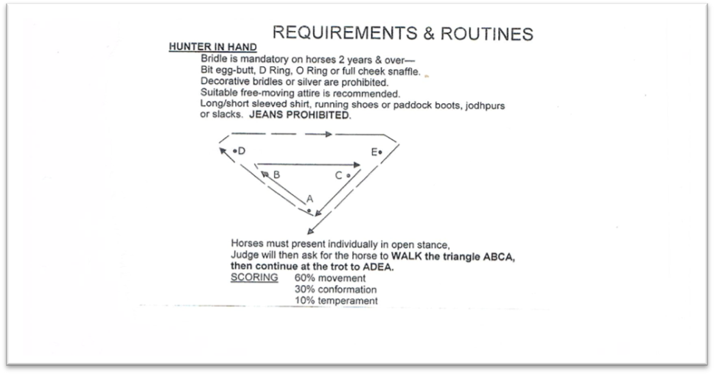
362. 3 years & over

WESTERN PERFORMANCE H.S.A.A. rules apply

Youth: 18 yrs & under
Amateur Owner: Must hold current Amateur Owner card.
Junior Horse: 5yrs & under Senior Horse: 6yrs & over
Beginner: Rider/Horse combination must not have won an open class. Any safe humane equipment is acceptable for beginners. Attire: A hat, long sleeved shirt & suitable boots.

WESTERN PLEASURE
363. Youth
364. Amateur Owner
365. Junior Horse
366. Senior Horse
367. Open
368. Beginner

WESTERN HORSEMANSHIP
369. Youth
370. Amateur Owner
371. Junior Horse
372. Senior Horse
373. Open
374. Beginner

HUNTER UNDER SADDLE
375. Youth
376. Amateur Owner
377. Junior Horse
378. Senior Horse
379. Open
380. Beginner

ENGLISH PLEASURE Ridden one handed. No spurs or whips. Jointed Snaffle Bit.
No cavesson or drop noseband. Shirt with tie. Hard hat or safety hat.
381. Youth
382. Amateur Owner
383. Open
384. Beginner



SHOWJUMPING Saturday Walk the course 8am & 8.30 am start

Entry fees payable when nominating at ring office before event. No refunds.

UNOFFICIAL CONTEST 2015 run under F.E.I. and F.F.A. Rules 22nd edition, as amended. Riders must be correctly dressed. No persons other than Judges, Stewards and competitors in class being judged are allowed into ring. APPROVED safety helmets must be worn. Events can be altered at the discretion of the ring Committee. Horses can only compete in 3 consecutive height classes.

All Saturday exhibitors are encouraged to participate in the Grand Parade commencing at 2.30pm on Saturday. All exhibitors leading, driving or riding an animal go into the lucky draw for
$1000 cash courtesy Frances Blake
Money to 4th place ribbons to 6th place.

Height classes Prizes 1st 2nd 3rd 4th
SJ 1. 60cm Height Class (A7)17 yrs & under entry $5 $20 $15 $10 $5
SJ 2. 60cm Height Class (A7)18 yrs & over entry $5 $20 $15 $10 $5
SJ 3. 75cm Height Class (A7)17 yrs & under entry $5 $20 $15 $10 $5
SJ 4. 75cm Height Class (A7)18 yrs & over entry $5 $20 $15 $10 $5
SJ 5. 90cm Height Class (A7) OPEN entry $8 $50 $25 $15 $10
SJ 6. 100cm Height Class (A7) OPEN entry $8 $50 $25 $15 $10

6 Bar under lights 5.30pm start

SJ 7. Junior 6 Bar - entry $8 $50 $25 $15 $10
(6 Bar entrants must have competed in at least 2 of the first 4 events)

SJ 8. Open 6 Bar - entry $12 $150 $80 $50 $25
(6 Bar entrants must have competed in at least 2 of the first 6 events)
Reminder: FIREWORKS 7.30pm Sat 16 May
SHOWJUMPING Sunday Walk the course 8am & 8.30am start
Height Classes

Prizes
1st 2nd 3rd 4th

SJ 9. 75cm Height Class (AM5) riders 17yrs & under entry $5 $30 $15 $10 $5

SJ10. Hit and Hurry 75cm class entry $8 $50 $25 $15 $5

SJ11. 90cm Height Class (AM5) - OPEN entry $8 $50 $25 $15 $5

SJ12. JUNIOR MINI GRAND PRIX under 17yrs entry $8 $ 50 $25 $15 $5

SJ13. OPEN MINI GRAND PRIX entry $12 $150 $80 $50 $25

JUNIOR starting height 75cm over 2 rounds Formal dress required for MINI GRAND PRIX.
OPEN starting height 100cm over 2 rounds
RIDDEN Ring 1 SUNDAY 8am
ENTRY FEE $ 4 per class
PRIZE MONEY $10 first, $ 6 second, $ 4 third unless states otherwise
RIBBONS to 3rd place

CHILDREN’S RIDING CLASSES

401. Tiny tot under 7 yrs. Must be led (not eligible for Champion)
402. Rider under 7 yrs
403. Rider 7 yrs & under 9 yrs
404. Rider 9 yrs & under 11 yrs
405. Rider 11 yrs & under 13yrs
406. CHAMPION & RESERVE CHAMPION Junior Rider (winner of classes 402 to 405eligible)

407. Rider 13 yrs & under 15 yrs
408. Rider 15 yrs & under 17 yrs
409. CHAMPION & RESERVE CHAMPION Senior Rider (winner of classes 407 & 408 eligible)
Sash & voucher for both Champion & Reserve- Browbands made to the winners choice up to $80 value courtesy …… SHOW SELECTION BROWBANDS

- OPEN CHAMPION Boy or Girl Rider under 17 years –
Winner of classes 406 & 409 to ride off for
The BECKETT FAMILY Trophy sash, trophy sponsored by MARGARET BECKETT

PONY HACK 14 H & UNDER
411. Maiden Pony Hack n/e 14hh
412. Novice Pony Hack n/e 13hh
413. Novice Pony Hack 13hh n/e 14hh
414. CHAMPION & RESERVE Novice Pony Hack ( winner of classes 411 to 413 eligible)

415. Open Pony Hack n/e 12hh
416. Open Pony Hack 12hh n/e 12.2hh
417. Open Pony Hack 12.2hh n/e 13hh
418. Open Pony Hack 13hh n/e 13.2hh
419. Open Pony Hack 13.2hh n/e14hh
420. Child’s Pony Hack Rider under 17 years
421. CHAMPION & RESERVE CHAMPION Open Pony Hack (winner of classes 415 to 420 eligible)

422. District Pony n/e 14hh
423. Best Educated Pony Hack n/e 14hh
424. Pair of Ponies n/e 14hh
425. Pleasure Pony n/e 14hh– (ridden in a snaffle bit, no whip, spurs or nosebands )

OPEN SHOW HUNTER PONY HACK (must not compete in any other open classes)
426. Show Hunter Pony Hack n/e 13hh
427. Show Hunter Pony Hack over 13hh & n/e 14hh
429. Show Hunter Pony Hack registered with AHHA over 13hh & n/e 14hh
430. Child’s Show Hunter Pony Hack (Rider under 17 years) over 13hh & n/e 14hh
431 Ladies/ Gent Show Hunter Pony Hack (rider 17 years & over) over 13hh & n/e 14hh
432. CHAMPION & RESERVE CHAMPION Open Show Hunter Pony Hack (winner of classes 426 to 431 eligible)

RIDDEN Ring 2 SUNDAY 8am
ENTRY FEE $ 4 per class
PRIZE MONEY $10 first, $ 6 second, $ 4 third unless states otherwise
RIBBONS to 3rd place

LADY RIDER 17 YRS & OVER
501. Lady Rider 17 years & under 21 years
502. Lady Rider 21 years & over

GENTLEMAN RIDER 17 YEARS & OVER
503. Gent rider 17 years & under 21 years
504. Gent rider 21 years & over
505. CHAMPION & RESERVE CHAMPION Lady or Gent Rider (winner of classes 501 to 504 eligible)
PAIRS
507. Pair of Junior Riders under 13 years
508. Pair of Senior Riders 13 & under 17 years
509. Adult and Child rider under 17 years
510. Lady Rider or Gent Rider in Pairs

511. SUPREME CHAMPION Open Rider (winner of classes 505 & 410 eligible) sash & trophy

GALLOWAY HACK – 14hh & N/E 15hh
512. Maiden Galloway Hack over 14hh n/e 15hh
512A. Novice Galloway Hack over 14hh n/e 14.2hh
513. Novice Galloway Hack over 14.2hh n/e 15hh
514. CHAMPION & RESERVE CHAMPION Novice Galloway Hack (winner of classes 512 to 513 eligible)

515. Lightweight open Galloway Hack over 14hh n/e 14.2hh
516. Lightweight open Galloway Hack over 14.2hh n/e 15hh
517. Heavyweight open Galloway Hack over 14hh n/e 14.2hh
518. Heavyweight open Galloway Hack over 14.2hh n/e 15hh
519. Child’s Galloway Hack (Rider under 17 years)
520. Ladies/ Gent Galloway Hack (17 years & over)
521. CHAMPION & RESERVE CHAMPION Open Galloway Hack (winner of classes 515 to 520eligible)

522. District Galloway hack over 14hh n/e 15hh
523. Best Educated Galloway Hack over 14hh n/e 15hh
524. Pair of Galloway Hacks over 14hh n/e 15hh
525. Pleasure Galloway– (ridden in a snaffle bit, no whip, spurs or noseband.) over 14hh n/e 15hh

OPEN SHOW HUNTER GALLOWAY HACK (must not compete in any other open classes)
526. Show Hunter Galloway Hack over 14hh n/e 14.2hh
527. Show Hunter Galloway Hack over14.2hh & n/e 15hh
528. Show Hunter Galloway Hack registered with AHHA over 14hh n/e 15hh
529. Child’s Show Hunter Galloway Hack (Rider under 17 years) over 14hh n/e 15hh
530. Ladies / Gent Show Hunter Galloway Hack (17 years & over) over 14hh n/e 15hh
531. CHAMPION & RESERVE CHAMPION Open Show Hunter Galloway Hack (winner of classes 526 to 530 eligible)

532. SUPREME CHAMPION Show Hunter Hack (winner of classes 432, 531& 642 eligible) sash & trophy

OFF THE TRACK – Ridden Entry form below open to horses that have trialled or raced in Australia or overseas
ENTRY FEE $ 4 per class
PRIZE MONEY $10 first, $ 6 second, $ 4 third unless states otherwise
RIBBONS to 3rd place
533 . Ridden OTT Hack open to horses that have trialled or raced in Australia or overseas. (See details & entry form below)
Embroidered rug, hood and tail bag set to winner courtesy OTT and ……………

The Off the Track series is exclusive to retired racehorses in the ACT/NSW.
To be eligible to compete, horses must have competed in an official trial or started in a race locally, nationally or internationally. This class is open to any height, weight, hunter or hack.
The winner receives an Off the Track prize pack and automatic entry into the Off the Track series final. Class winners will be ineligible to compete in the class for the remainder of the season. 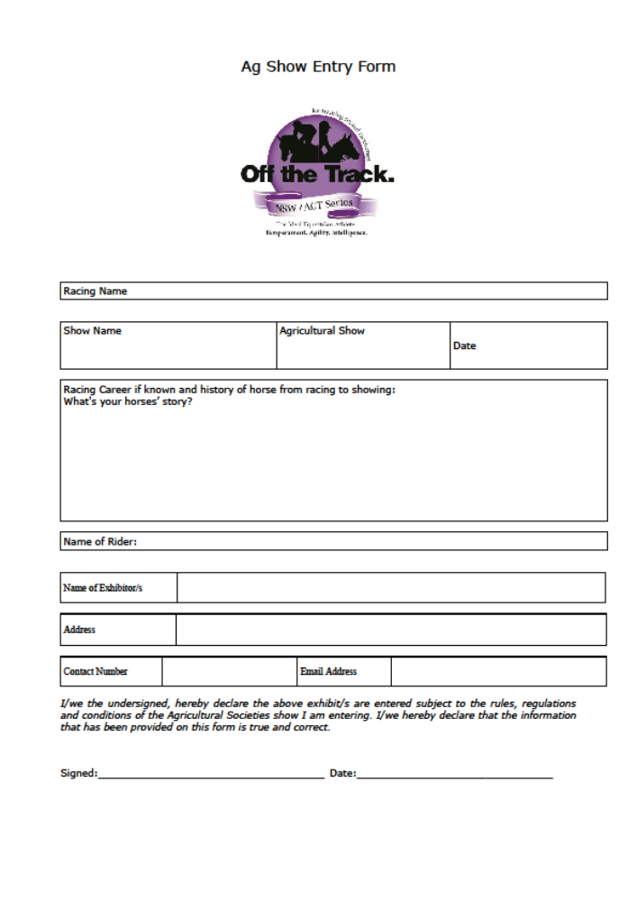

RIDDEN Ring 3 SUNDAY 8am
ENTRY FEE $ 4 per class PRIZE MONEY $10 first, $6 second, $4 third unless states otherwise Ribbons to 3rd place
DISTRICT SENIOR GIRL, BOY RIDER
601. Girl or Boy Rider 13 years & under 15 years
602. Girl or Boy Rider 15 years & under 17 years
603. CHAMPION & RESERVE CHAMPION District Senior G/B Rider (winner of classes 601 & 602 eligible)

604. District Lady Rider 17 years & under 25 years
605. District Gent Rider 17 years & under 25 years
606. District Lady Rider over 25 years
607. District Gent Rider over 25 years
608. CHAMPION & RESERVE CHAMPION District Adult Rider (winner of classes 604 to 607 eligible)

DISTRICT JUNIOR GIRL AND BOY RIDER
609. Girl or Boy Rider under 7 years must be led (not eligible for Champion)
610. Girl or Boy Rider under 7 years
611. Girl or Boy Rider 7 years & under 9 years
612. Girl or Boy Rider 9 years & under 11 years
613. Girl or Boy rider 11 years & under 13 years
614. CHAMPION & RESERVE CHAMPION District Junior G/B Rider (winner of classes 610 to 613 eligible)

615. SUPREME CHAMPION District Rider sash & voucher donated by HORSELAND Coffs Harbour
RIDING FOR THE DISABLED (winner of classes 603, 608 & 614 eligible)
616. Rider under 15 years
617. Rider 15 years & over
618. CHAMPION & RESERVE CHAMPION RDA (Winner of classes 616 & 617 eligible)

HACKS over 15hh
619. Maiden Hack over 15hh
620. Novice Hack over 15hh to 15.2hh
621. Novice Hack over 15.2hh to 16hh
622. Novice Hack over 16hh
623. CHAMPION & RESERVE CHAMPION NOVICE HACK (winner of classes 619 to 622 eligible)

624. Open Hack over 15hh to 15hh
625. Open Hack over 15.2hh to 16hh
626. Open Hack over 16hh to 16.2hh
627. Open Hack over 16.2hh
628. Ladies/Gent Hack (rider 17 years & over)
629. Childs Hack (rider under 17 years)
630. CHAMPION & RESERVE CHAMPION OPEN HACK (winner of classes 624 to 629 eligible)

631. District Hack over 15hh
632. Best Educated Hack over 15hh
633. Pair of Hacks over 15hh
634. Pleasure Hack over 15hh ridden in a snaffle bit, no whip, spurs or noseband.
635. SUPREME CHAMPION Hack (winners of classes 421, 521, 630 eligible) sash & trophy
OPEN SHOW HUNTER HACK (must not compete in any other open classes)
636. Show Hunter Hack over 15hh n/e 15.2hh
637. Show Hunter Hack over 15.2hh & n/e 16hh
638. Show Hunter Hack over 16hh
639. Show Hunter Hack registered with AHHA over 15hh
640. Child’s Show Hunter Hack (Rider under 17 years) over 15hh
641. Ladies/ Gent Show Hunter Hack (17 years & over) over 15hh
642. CHAMPION & RESERVE Open Show Hunter Hack (winner of classes 636 to 641 eligible)Champion to 532
643. SUPREME CHAMPION District Hack sash, rug & voucher donated by
(winner of classes 422, 522 & 631 eligible) HORSELAND Coffs Harbour

HEAVY HORSES Sunday 10am Cattle Arena

RIDDEN
701. Heavy Horse Ridden - open to all – well controlled stallions allowed

DRIVEN - WORKING CLASS (minimum gear: to be driven in winkers, collar, back band and chains)
702. Open Senior Long Rein obstacle course
703. Junior Long Rein obstacle course- contestant to be under 16 years, accompanied by an adult)
704. Single Horse in a Slide obstacle course
705. Child 9 yrs & under 16 yrs accompanied by an adult in a Single Horse Slide
706. Horse in Cart or Wagon
707. CHAMPION Driven sash & trophy sponsored by CABA’S DRAPERY
708. Open costume class – all heavy horses



CONDITIONS – Coffs Harbour Show Society Inc.

HENDRA VIRUS:Hendra vaccination is not compulsory but due to the presence of flying fox in the mangroves Hendra vaccinated horses will have first priority for stable bookings. Please note: If there were to be a Hendra case diagnosed, unvaccinated horses would not be allowed home until the quarantine period ended.
GENERAL: Only Judges, stewards & competitors in the class being judged will be allowed in the ring. Competitors in each class must report to the Judge within three minutes of the final call for that class. No more competitors in that class will be admitted to the ring and judging will proceed. All competitors compete at their own risk and must be wearing an ID band on their wrist.
WAIVER AND RISK WARNING: All competitors at the Coffs Harbour Show compete entirely at their own risk. Entries are only accepted on this understanding. Completed & signed Waiver & Risk Warning forms must be handed in when registering & before entering ring.
ID NUMBERS: ID Numbers will be issued. No competitor will be allowed into the ring without an ID Number. Names of horses will be required. Any incidents/accidents will need to be reported & recorded. Names and witnesses will be required.
CLASS ENTRY FEE: Entry $4.00 unless otherwise stated. Entry tickets from Ring Office on day of Show. Pairs entry fee $4.00 per pair. Nominations for Jumping & Sporting are to be made at Ring Office and close prior to the start of the event.
PRIZEMONEY: $10.00 1st, $6.00 2nd, $4.00 3rd unless otherwise stated. All prize money will be paid in ring or at Ring Office upon presentation of signed prize cards. Prizes not collected by the close of Show on Sunday will be forfeited. Prizes won’t be posted. Pairs prizes will be shared as is the entry fee.
REGISTERED CLASSES: Are led unless stated otherwise. Horses are required to be registered/recorded in appropriate studbook. Registration papers are to be produced on request.
HEIGHT CLASSES: Are led unless otherwise stated. Horse owners are required to be in possession of a current height certificate which must be produced if required. Either of the following is acceptable:1.Official EFA Life or Annual Certificate. 2.Official current height certificate accepted.
HEIGHT CLASSIFICATIONS: PONY 14 hands & under, GALLOWAY over 14 hh & not exceeding 15hh, HORSE over 15 hh. If horse is shod 12.7mm (1/2 inch) is allowed for shoes.
OUTSIDE ASSISTANCE: Communication between competitors and other parties by way of word, radio or any other method is prohibited. If found to be in breach of this ruling, competitors and their exhibits may be dismissed from the event and from the Showgrounds & competitors names will be forwarded to the ASC.
STALLIONS: Not eligible to compete in ridden classes unless specified. All stallions must be under constant control and must be wearing a bit.
DRUG TESTING: Drug testing may be carried out at this Show. Any competitor found to have breached the ASC Disputes and Disciplinary Regulations will be investigated by the ASC Disciplinary Committee.
APPEALS: An appeal must be lodged by the plaintiff with the Chief Steward within 30 Minutes of completion of the class judging. The Appeal must be in writing and accompanied by $50.00 which will be refunded by the Secretary if the appeal is upheld. If appeal is lost, the society will retain the deposit.
HEAD PROTECTION: Approved safety helmets must be worn by all competitors aged 17 years and under and are recommended for all competitors in ridden & sporting events.
MARSHALLING AREA: All competitors are to assemble in the designated marshalling area and under the instruction of gatekeeper or announcer, are to proceed directly into ring.
BITUMEN ROADWAYS & ENTRY / EXIT LANE are to remain free of horses at all times.
HORSE STABLES: A limited number of stables will be available for rental at $10 per night. You will need to secure your own gates with rope or straps. Allotted stabling cannot be changed because of uncontrollable horses. Stables to be cleaned when vacated.
CAMPING ON GROUNDS: Use Stable Booking form. Camping fee of $10 per person per night (children under school age are free) is payable by competitors wishing to stay on the grounds overnight. Campers will receive a “paid camping” voucher which must be placed inside the front (driver’s side) windscreen of their vehicle. Competitors should pay for camping when paying for stables. Horses are not permitted in camping Area 1. Electric fences not permitted on grounds.
ELECTRICAL EQUIPMENT: Please check all electrical equipment prior to entering Showground. Electric leads must be mounted overhead. Exhibitors intending to bring electrical equipment to the Showground will be required to ensure that such equipment is fitted with earth leakage circuit breakers and that all electrical leads, tools and appliances have been inspected and tagged by a licensed electrical contractor. Exhibitors who do not comply will not be allowed to exhibit at the Showground. Electric fencing will not be allowed on Showground.
VEHICLE ACCESS: Direct access for all vehicles is via Tom Jung Avenue. Enter the Showground’s northern entrance gate & follow road to stable area. Pay to enter Show at rear entry. Vehicles strictly prohibited from parking under trees.
SELF REGULATION IS REQUIRED: Competitors will not be permitted to exhibit if they avoid paying camping fees, use stables not allocated to them or cause any inconvenience to other competitors.
DEFINITIONS: NOVICE is a Horse, Pony or Galloway that has not won an Open Championship at an Agricultural Show.
MAIDEN is a Horse, Pony or Galloway that has not won a first prize in any hack class at any Show.
DISTRICT horse and rider must be residents of the towns or suburbs listed on page 18.

VET ON CALL Pacific Vetcare 6652 3455

Listed are the towns & suburbs eligible for District events.

ARRAWARRA 2456
ARRAWARRA HEADLAND 2456
BARCOONGERE 2460 ***
BOAMBEE 2450
BOAMBEE EAST 2452
BONVILLE 2450
BROOKLANA 2450
BUCCA 2450
BUNDAGEN 2454
COFFS HARBOUR 2450
CORAMBA 2450
CORINDI 2456
CORINDI BEACH 2456
DIRTY CREEK 2460
EMERALD BEACH 2456
GLENREAGH 2450***
KARANGI 2450
KORORA 2450
LOWANNA 2450
MOONEE BEACH 2450
MULLAWAY 2456
NANA GLEN 2450
NORTH BOAMBEE VALLEY 2450
RED ROCK 2456 ***
SAFETY BEACH 2456
SANDY BEACH 2456
SAPPHIRE BEACH 2450
SAWTELL 2452
TOORMINA 2452
ULONG 2450
UPPER CORINDI 2456
UPPER ORARA 2450
WOOLGOOLGA 2456
*** Suburb is across councils

SATURDAY SPECIAL PRIZES
134. Ring 1 SUPREME CHAMPION Registered Led Horse sash, trophy & voucher
(winner of classes 105,109,113,117,121,125, 129, 133 eligible) donated by NORCO RURAL Coffs Harbour

229. Ring 2 SUPREME CHAMPION Registered Led Pony sash, trophy & voucher (winner of 204, 208, 212, 216, 220, 224, 228 & 232) donated by NORCO RURAL Coffs Harbour

250. SUPREME CHAMPION Registered Miniature Horse sash & trophy
(Winner of classes 237, 241, 245, 249 eligible) donated by CABA’S DRAPERY

333. Ring 3 SUPREME CHAMPION Registered Led English or Western sash & trophy
(Winner of 304, 308, 312, 316, 320, 324, 328 eligible)

355. SUPREME CHAMPION Registered Led Heavy Horse sash & trophy by GLENGALLAN SHIRES (Winner of classes 339, 344, 349 & 354 eligible)

145. The BRAY FAMILY Memorial Trophy sponsored by the BRAY FAMILY TRUST
Best turned out Horse and Rider 13-25yrs from Coffs Harbour Pony Club, mounted on regular Pony Club mount, dressed in Pony Club Uniform and using own equipment to the satisfaction of the Chief Instructor.

146. The KAYE HANSON Memorial Shield sponsored by the COFFS HARBOUR SHOW SOCIETY INC.
Best turned out Horse and Rider under 13 years from Coffs Harbour Pony Club, mounted on regular Pony Club mount, dressed in Pony Club Uniform and using own equipment to the satisfaction of the Chief Instructor.

363. BEST YOUNG STOCK OF THE SHOW trophy & prizes donated by BEACHFIELDS QUARTER HORSES
(Winner of classes 356, 357, 358 eligible)

GRAND CHAMPION Registered Led – HORSE OF SHOW
134. SUPREME CHAMPION Registered Led Horse 233. SUPREME CHAMPION Registered Led Pony 333. SUPREME CHAMPION Registered Led Western 250. SUPREME CHAMPION Registered Led Miniature Horse eligible
sash & trophy sponsored & presented by NORTHSTATE FINANCE

SUNDAY SPECIAL PRIZES
- SUPREME CHAMPION Open Rider sash & trophy
(winner of classes 505 & 410 eligible)

507. OPEN CHAMPION Boy or Girl Rider The Beckett Memorial trophy – donated by MARGARET BECKETT
(Winner of classes 406 & 409)

532. SUPREME CHAMPION Show Hunter Hack sash & trophy
(winner of classes 432, 531& 642 eligible)

533. OFF THE TRACK Embroidered rug, hood and tail bag set to winner courtesy: OTT &
(exclusive to retired racehorses in the ACT/NSW)

615. SUPREME CHAMPION District Rider sash & voucher donated by HORSELAND Coffs Harbour
(winner of classes 603, 608 & 614 eligible)

635. SUPREME CHAMPION Hack sash & trophy
(winners of classes 421, 521, 630 eligible)

643. SUPREME CHAMPION District Hack sash, rug & voucher donated by HORSELAND Coffs Harbour
(winner of classes 422, 522 & 631 eligible)

